**Excel Lecture-3**

* **OFFSET**

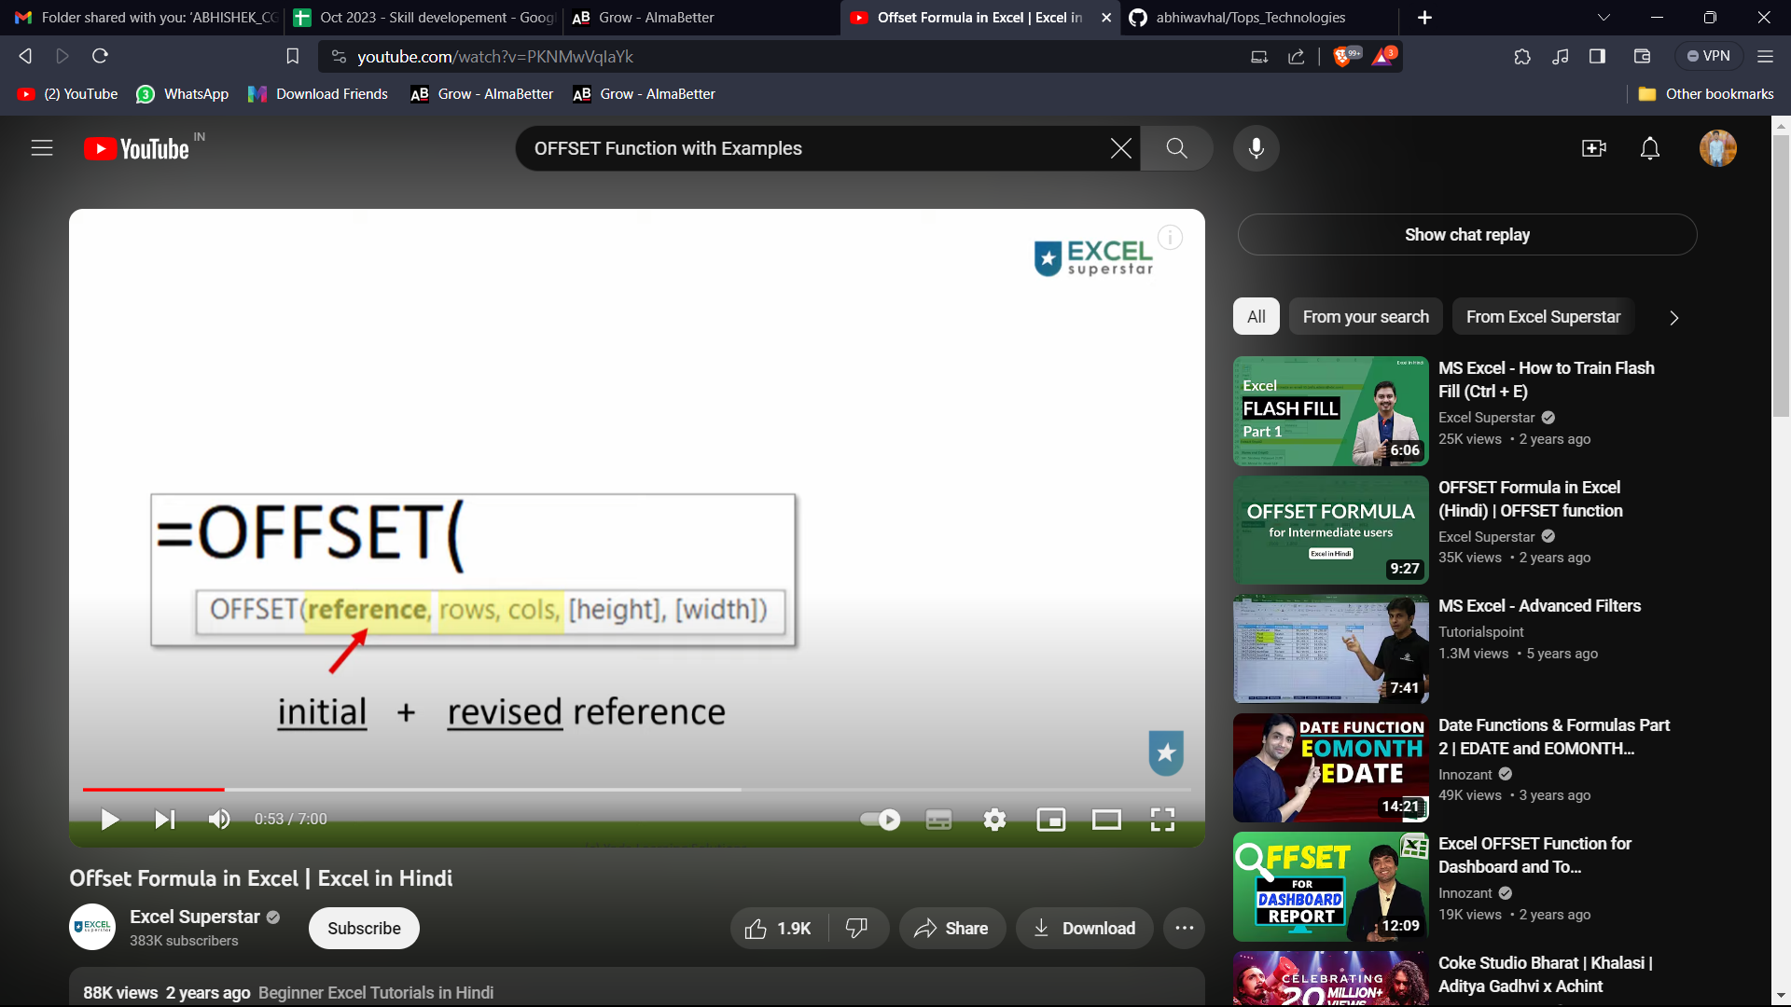

* + - For Example

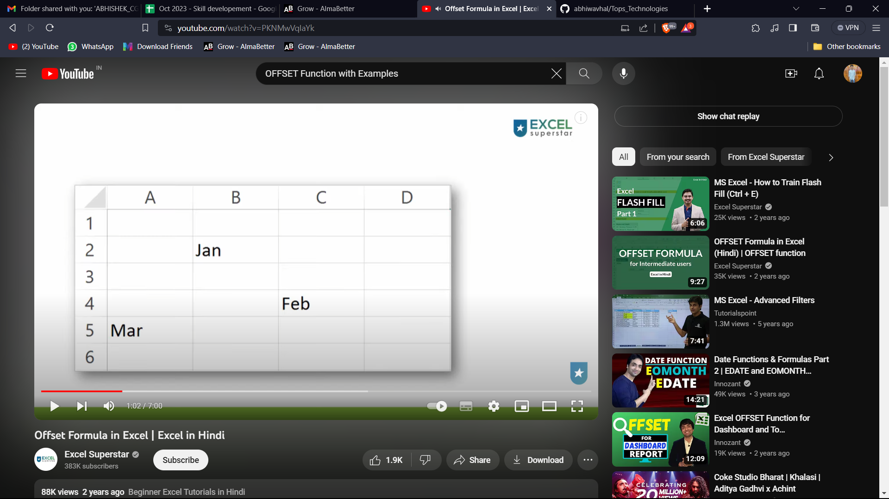

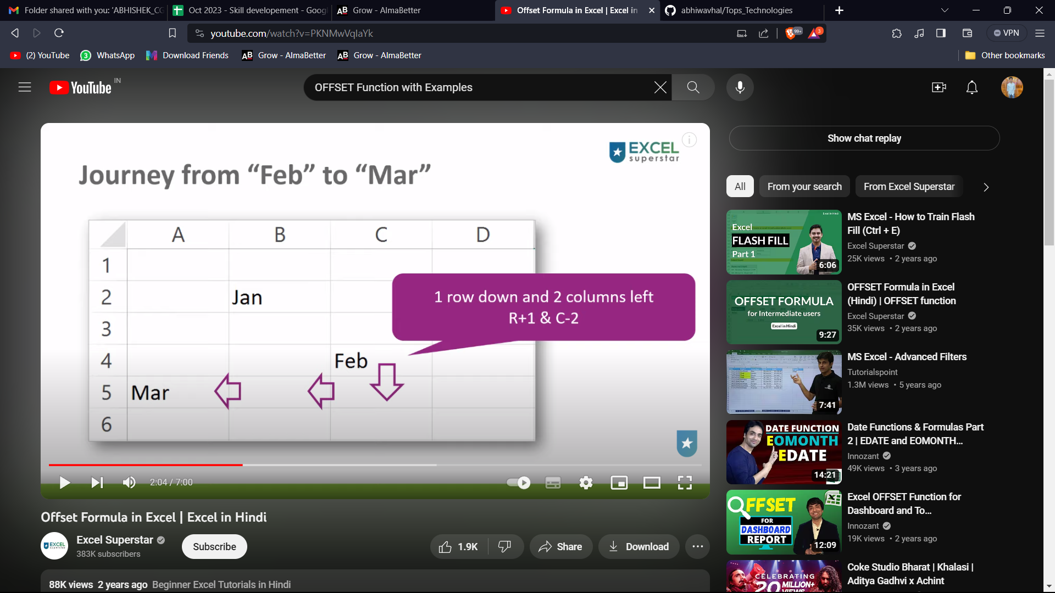

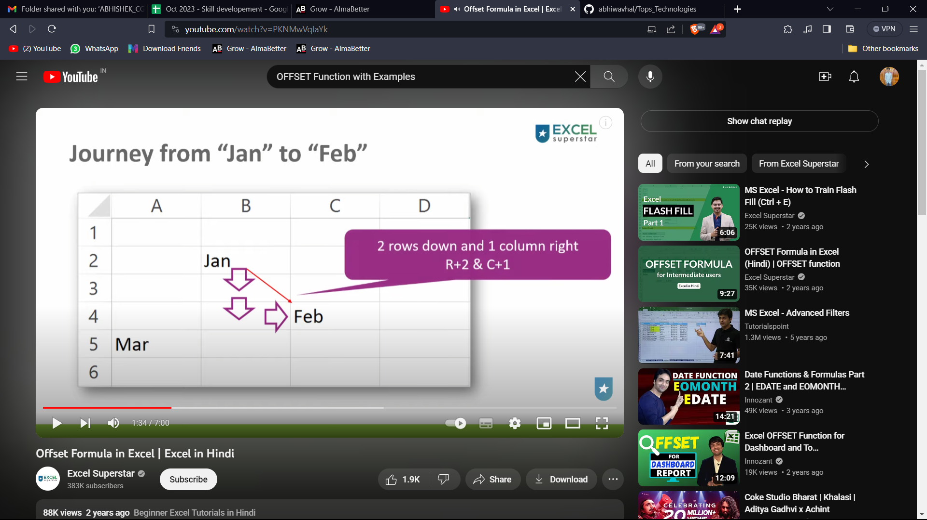

* + - Initial reference point is Jan
    - Revised Reference point is Feb



* **CHOOSE**
  + - Use
* **REMOVE DUPLICATES:**
  + - Remove Duplicate with Duplicate feature
    - Will Delete Original Data set
    - Unique Single column
    - Unique Table